**Tensors in ML**

What are Tensors and why we are learning?

**Tensors:** are basically a data structure. A procedure of storing the data. We are learning Tensors because any library like sci-kit learn etc uses Tensor data structure. In general tensor is a container in which we store the numbers.

A tensor is a generalization of vectors and matrices and is easily understood as a multidimensional array.

A vector is a one-dimensional or first order tensor and a matrix is a two-dimensional or second order tensor.

Tensor notation is much like matrix notation with a capital letter representing a tensor and lowercase letters with subscript integers representing scalar values within the tensor.

|  |  |
| --- | --- |
| 1  2  3 | t111, t121, t131     t112, t122, t132     t113, t123, t133  T = (t211, t221, t231),  (t212, t222, t232),  (t213, t223, t233)       t311, t321, t331     t312, t322, t332     t313, t323, t333 |

1. **0D Tensor / Scalar:** Tensors which are having zero number of dimensions. i.e (2) -> scalars or 0D tensor.

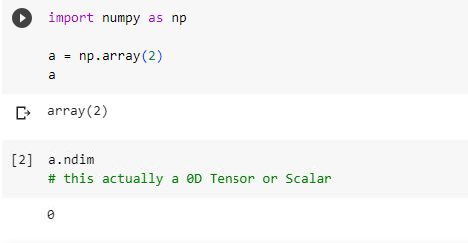

Tensor and N-dimensional array are the same thing. When ever you want to know the dimension of the array you use ndim() function of numpy.

1. **1D Tensor / Vector:** Whenever you have a single it will be the 1D Tensor or a vector.

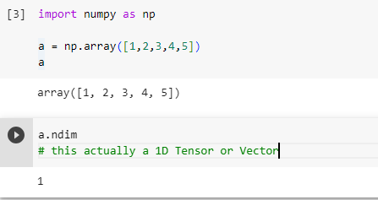

This tensor is 1D and if we ask about this vector then this will 5D vector.

Tensors are collection of 0D tensor and vectors are collection of scalars and matrices are collection of vectors.

1. **2D Tensor / Matrices:** 2D Tensors or Matrices are basically the collection of vectors.

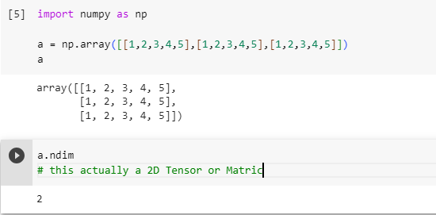

1. **ND Tensor:** will be the collection of N-1 D tensor. There are no tensor more than 5D.
2. **Rank, Axes and shape**: (No of Axis = Rank = No of Dimension). Shape is something how much items we can store in its single axis. i.e if row axis has 3 rows col axis has 5 col then its shape will be (3,5).

When ever you have data set in ML you can denote it with Matrix. Matrix is a collection of vectors with this definition every row of the dataset is a vector and vector have dimensions based on the columns of the dataset. Where Matrix is collection of 1D Tensors or Vectors. And matrix will always be 2D Tensor because it has rows and cols. So keep this scenario in your mind forever.

**3D Tensors** are used in NLP. Example as follows

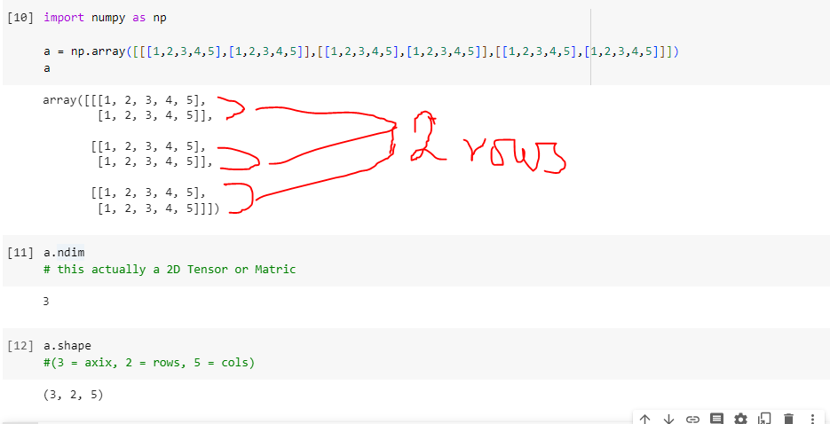

As we 3D Tensor is collection of 2D Tensors. So in every 2D Tensors there are 2 Rows and 5 Cols. Axis = 3 because we have 3 ndim() value.

**4D Tensors** are used image processing. **5D Tensors** are used in videos.